1)Problem Statement:
You work for XYZ Corporation. To maintain the security of the AWS account and
the resources you have been asked to implement a solution that can help easily
recognize and monitor the different users. Also, you will be monitoring the
machines created by these users for any errors or misconfigurations.
Tasks To Be Performed:
1. Create a CloudWatch billing alarm which goes off when the estimated
charges go above $500.
2. Create a CloudWatch alarm which goes off to an Alarm state when the
CPU utilization of an EC2 instance goes above 65%. Also add an SNS
topic so that it notifies the person when the threshold is crossed.

CloudWatch Billing Alarm (>$500)

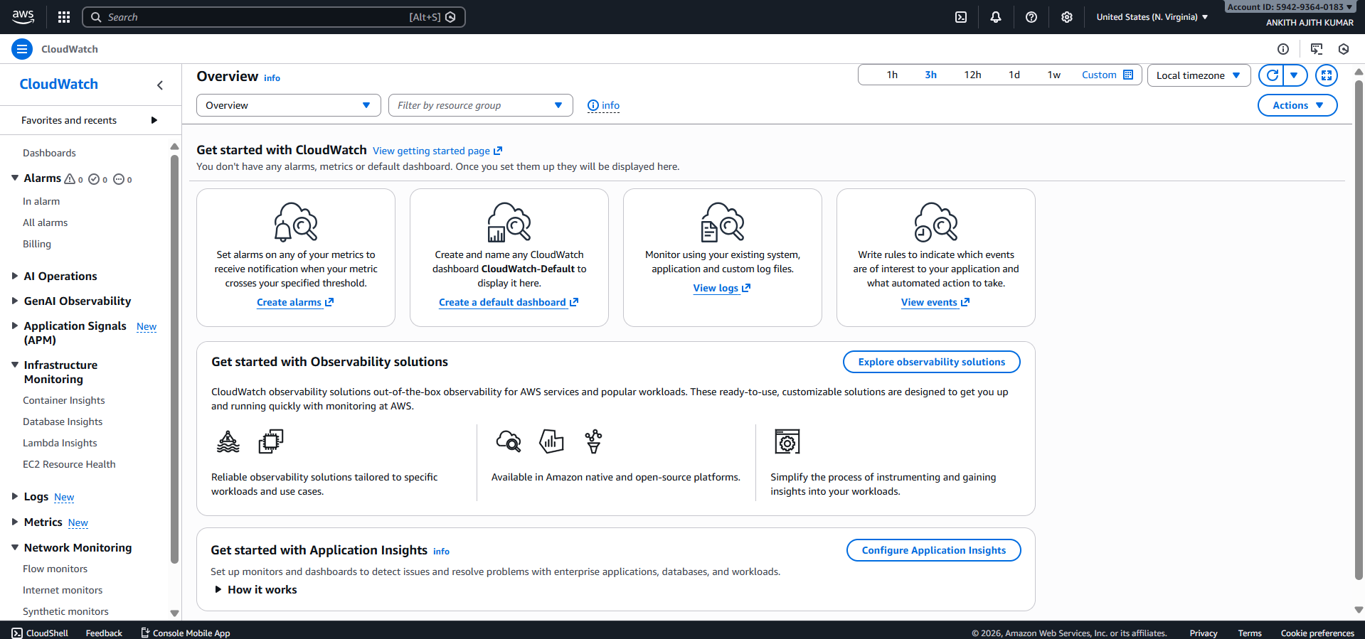
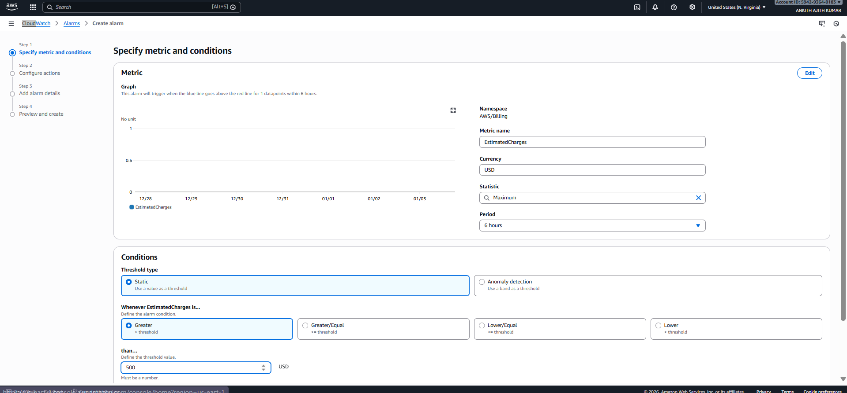

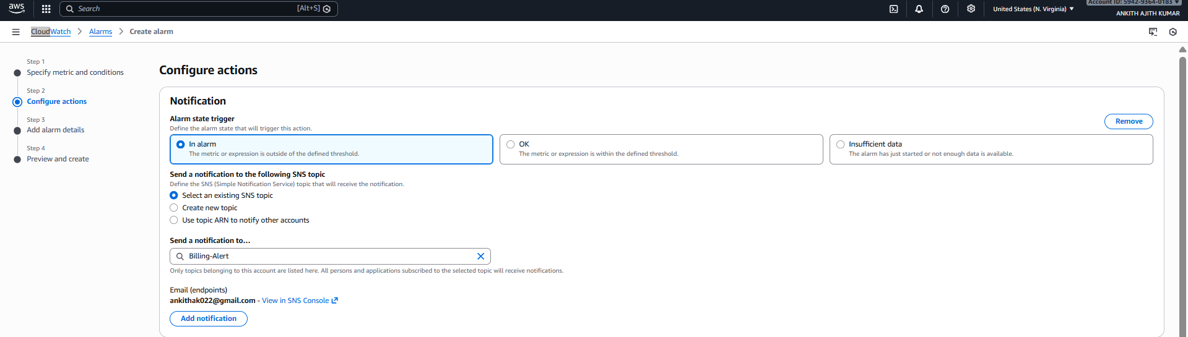
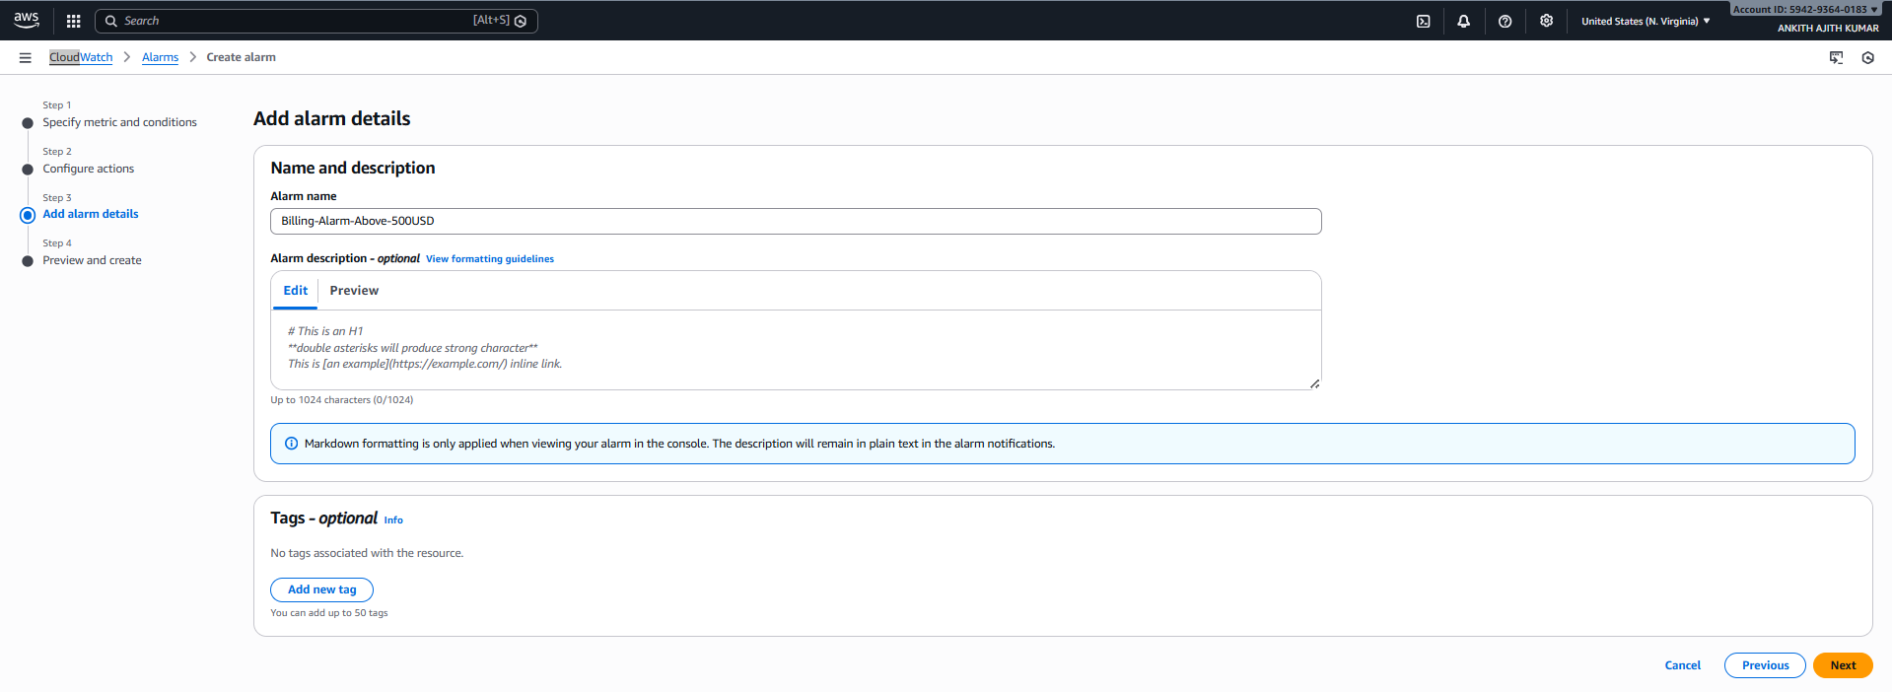
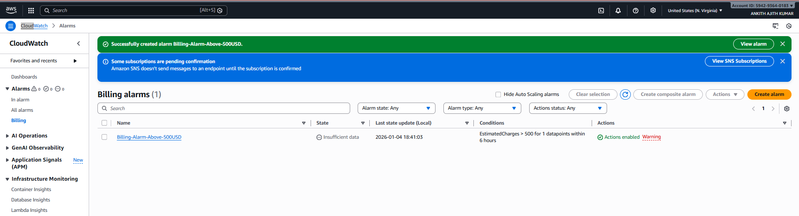

TASK 2: EC2 CPU Utilization Alarm (>65%)

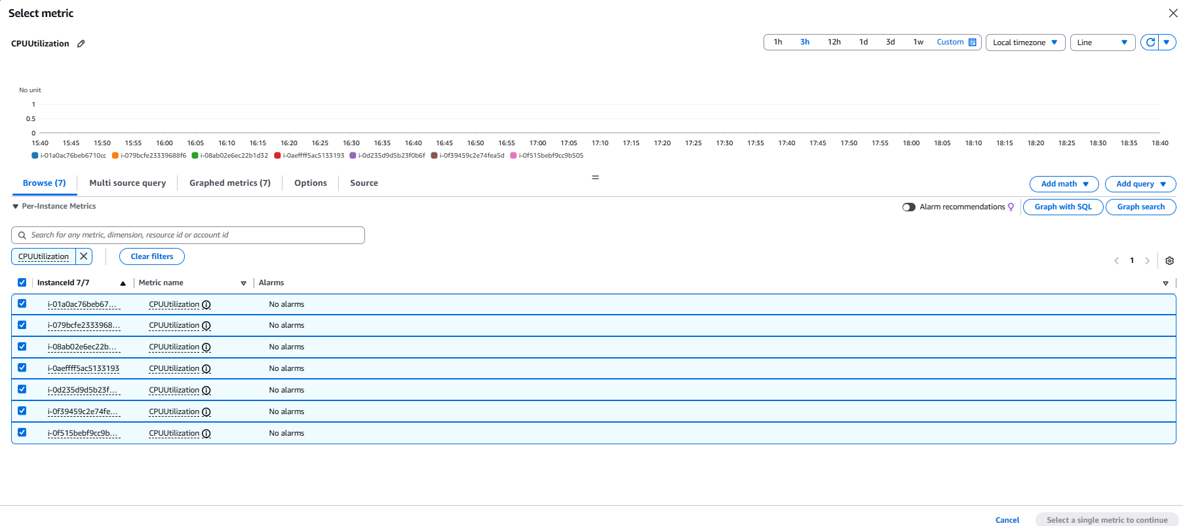
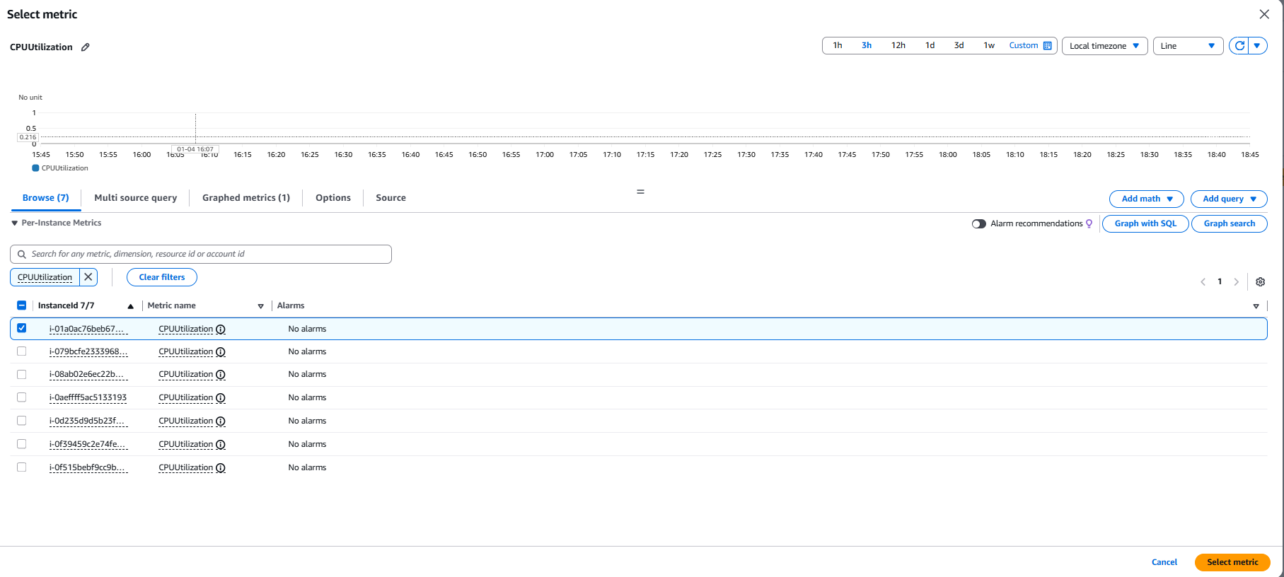
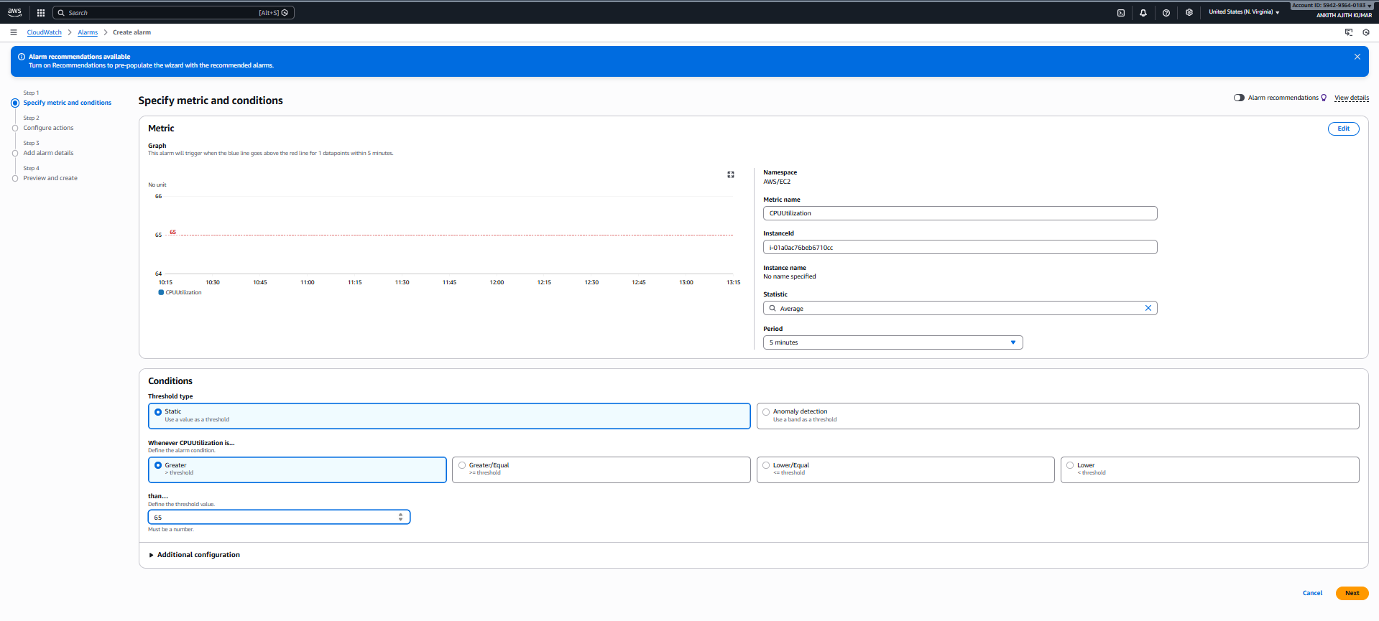

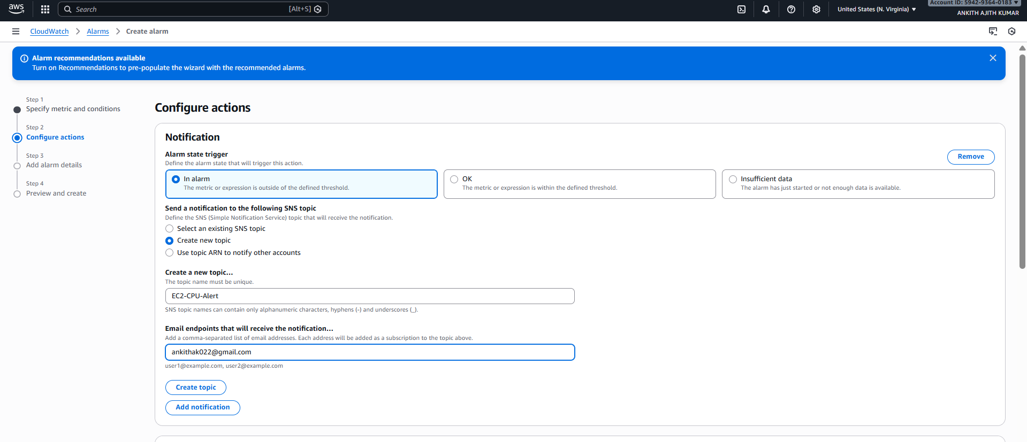
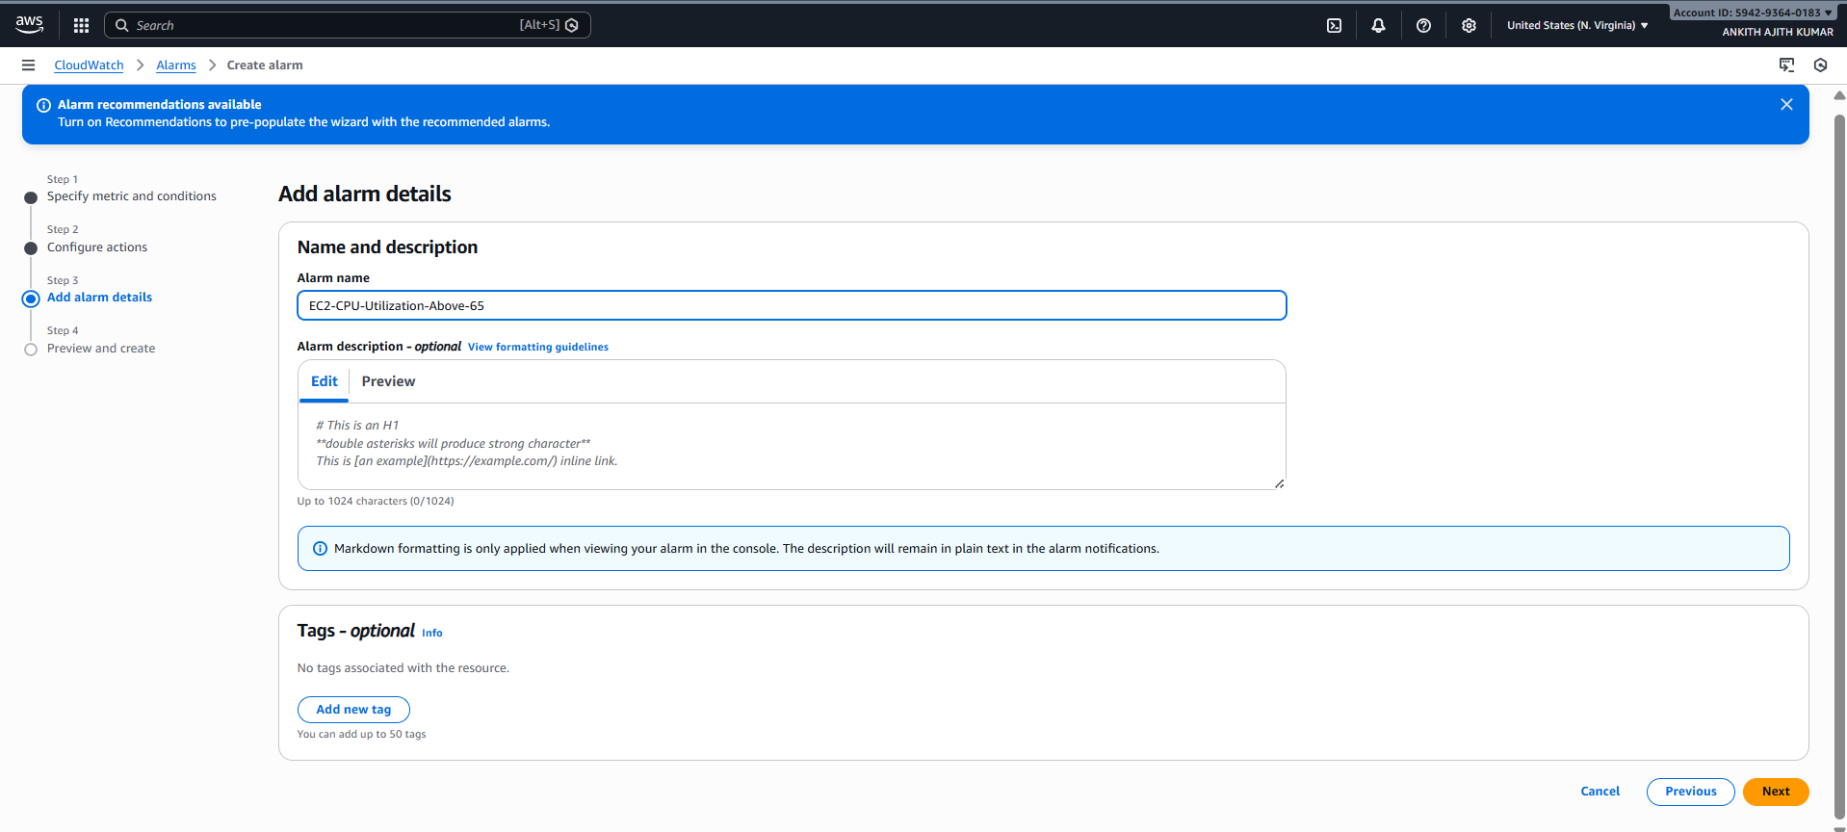
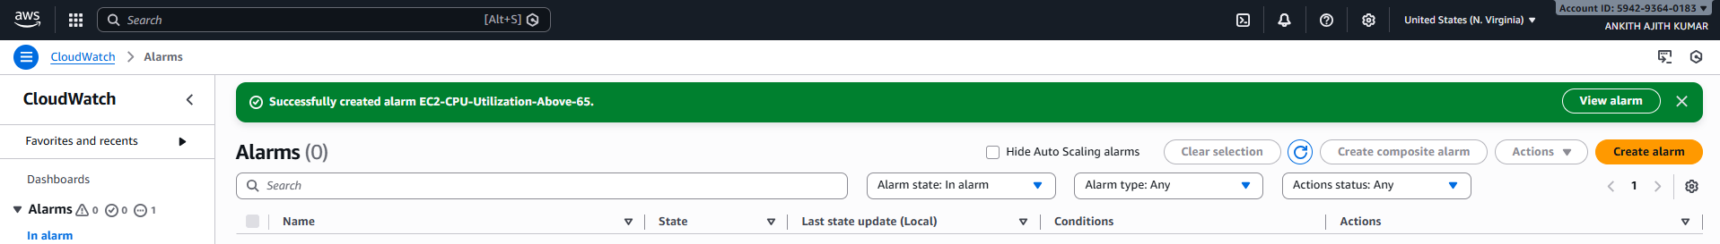

2)Problem Statement:
You work for XYZ Corporation. To maintain the security of the AWS account and
the resources you have been asked to implement a solution that can help easily
recognize and monitor the different users. Also, you will be monitoring the
machines created by these users for any errors or misconfigurations.
Tasks To Be Performed:
1. Create a dashboard which lets you check the CPU utilization and
networking for a particular EC2 instance.

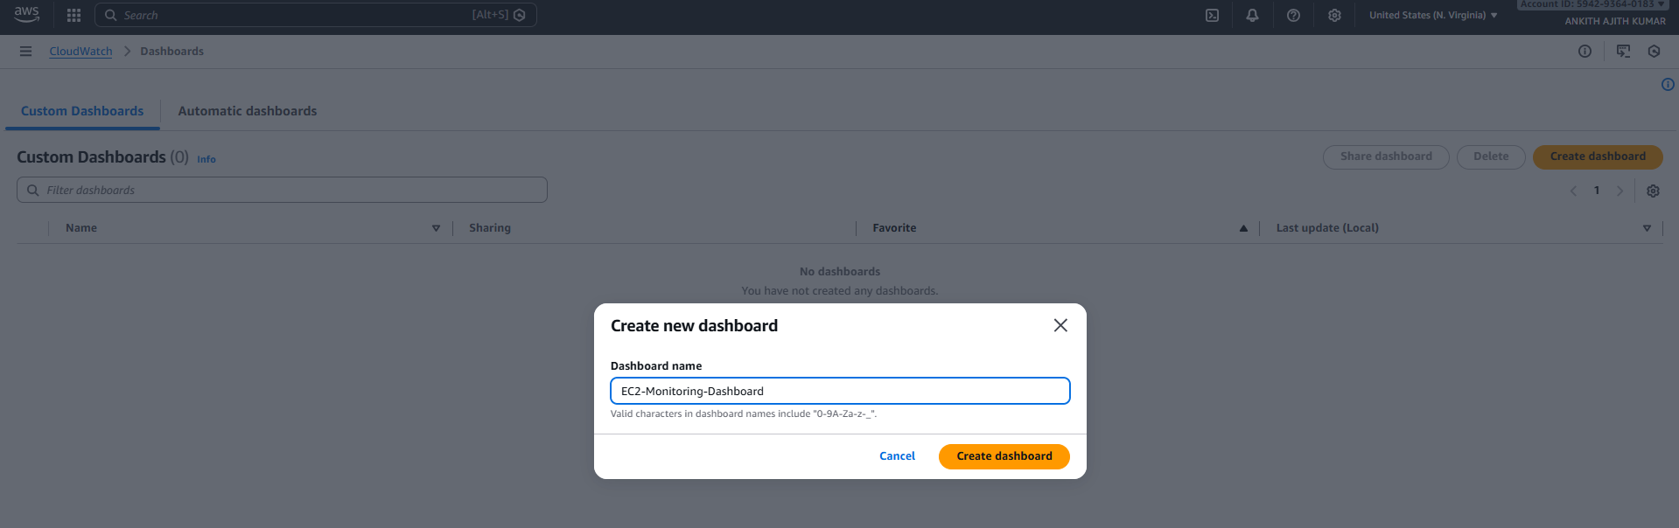
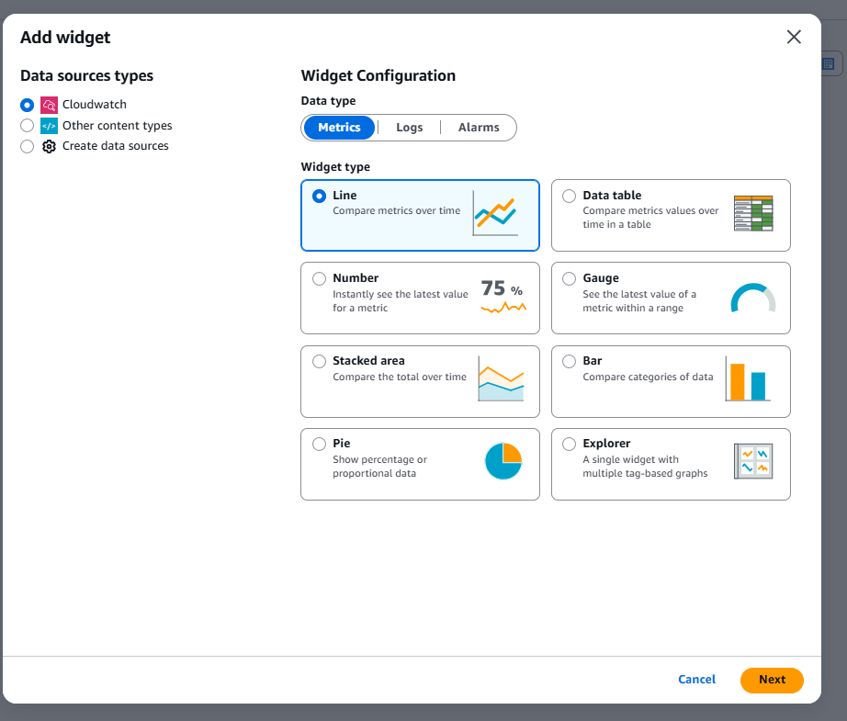

EC2
→ Per-Instance Metrics
→ CPUUtilization

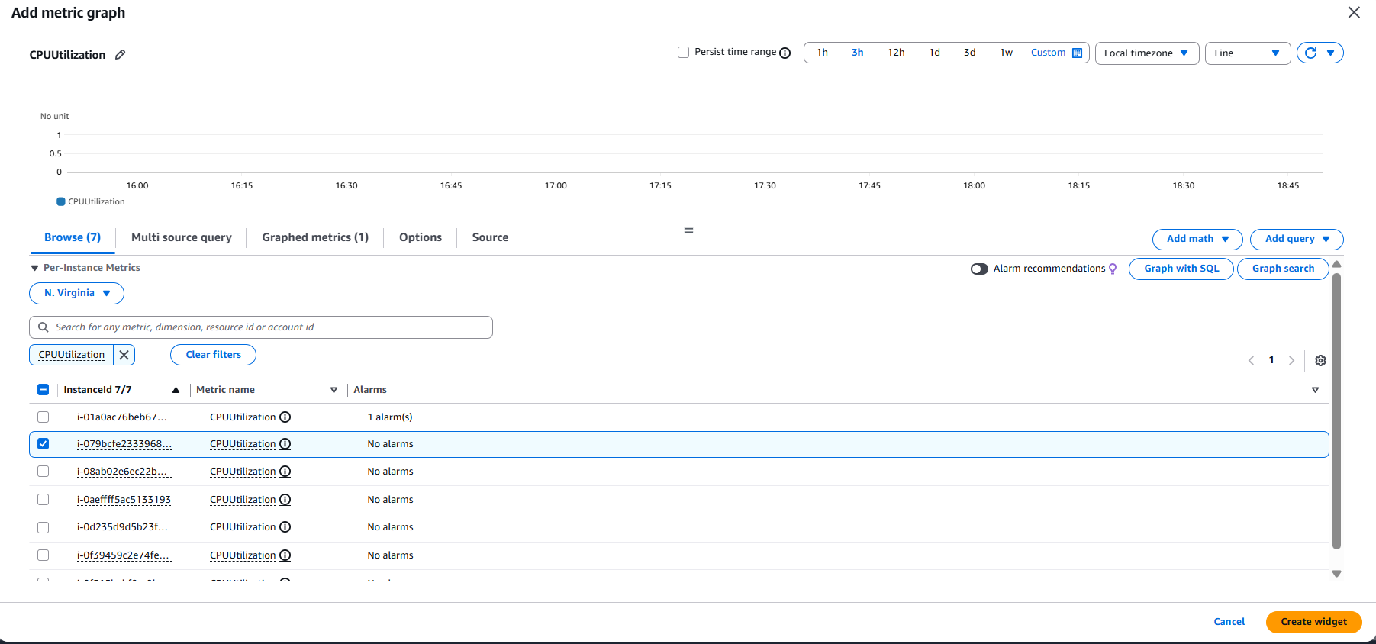
EC2
→ Per-Instance Metrics
→ NetworkIn
→ NetworkOut

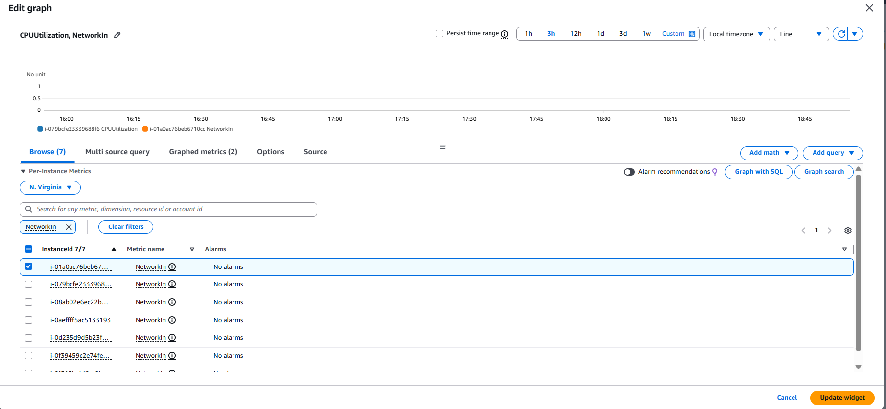
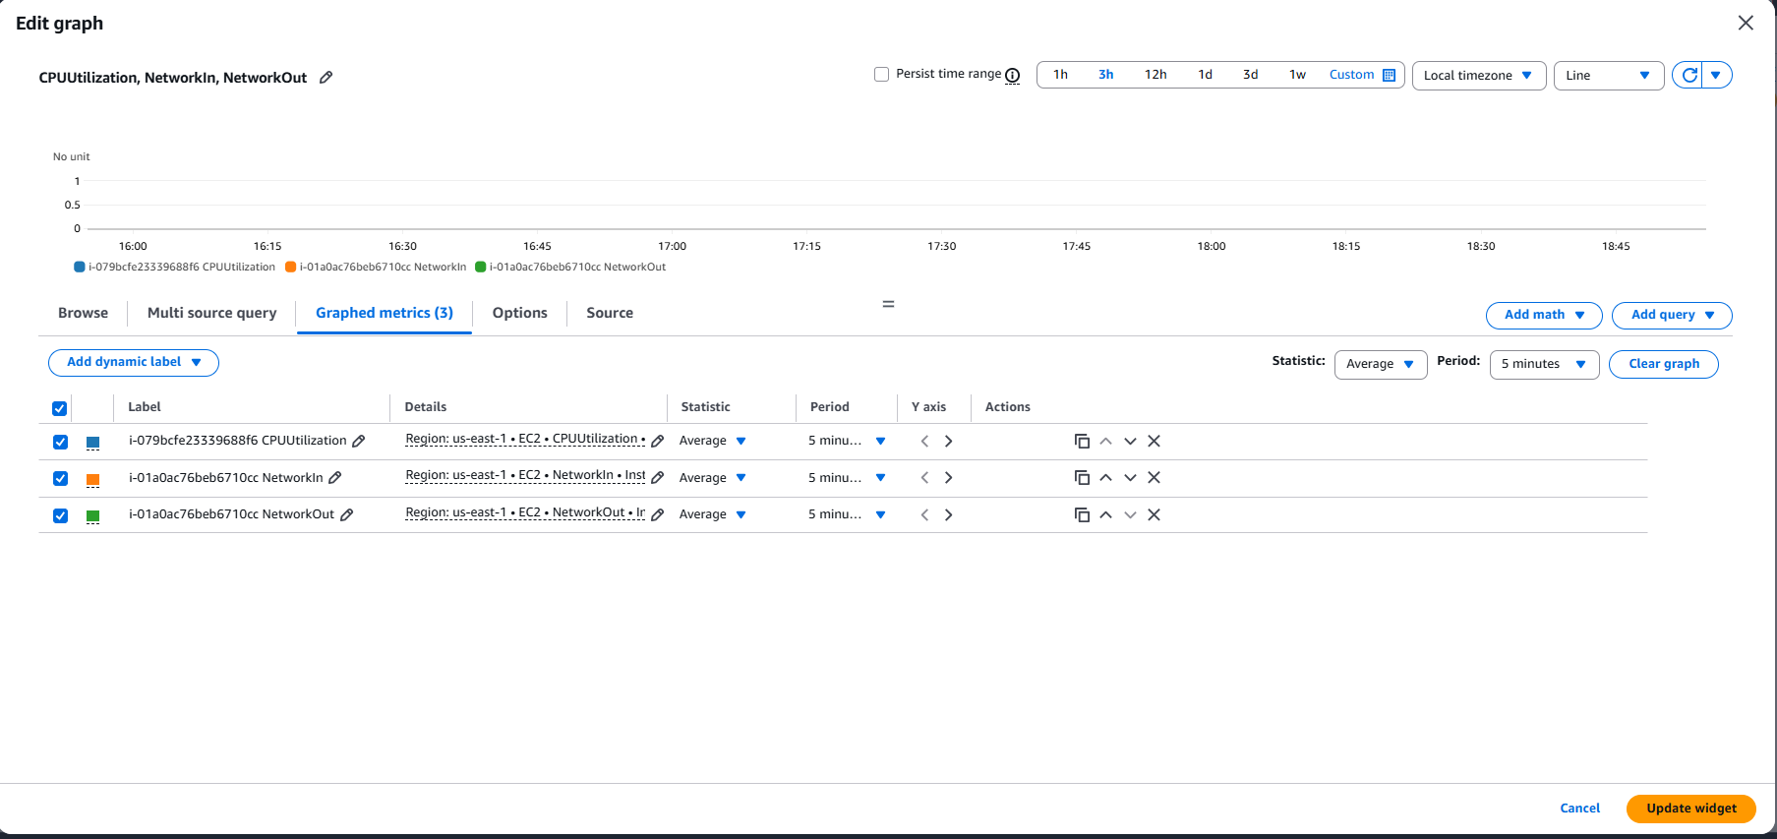

3)Problem Statement:
You work for XYZ Corporation. To maintain the security of the AWS account and
the resources you have been asked to implement a solution that can help easily
recognize and monitor the different users.
Tasks To Be Performed:
1. Create policy number 1 which lets the users to:
a. Access S3 completely
b. Only create EC2 instances
c. Full access to RDS
2. Create a policy number 2 which allows the users to:
a. Access CloudWatch and billing completely
b. Can only list EC2 and S3 resources
3. Attach policy number 1 to the Dev Team from task 1
4. Attach policy number 2 to Ops Team from task 1

TASK 1: Create Policy Number 1 (Dev Policy)

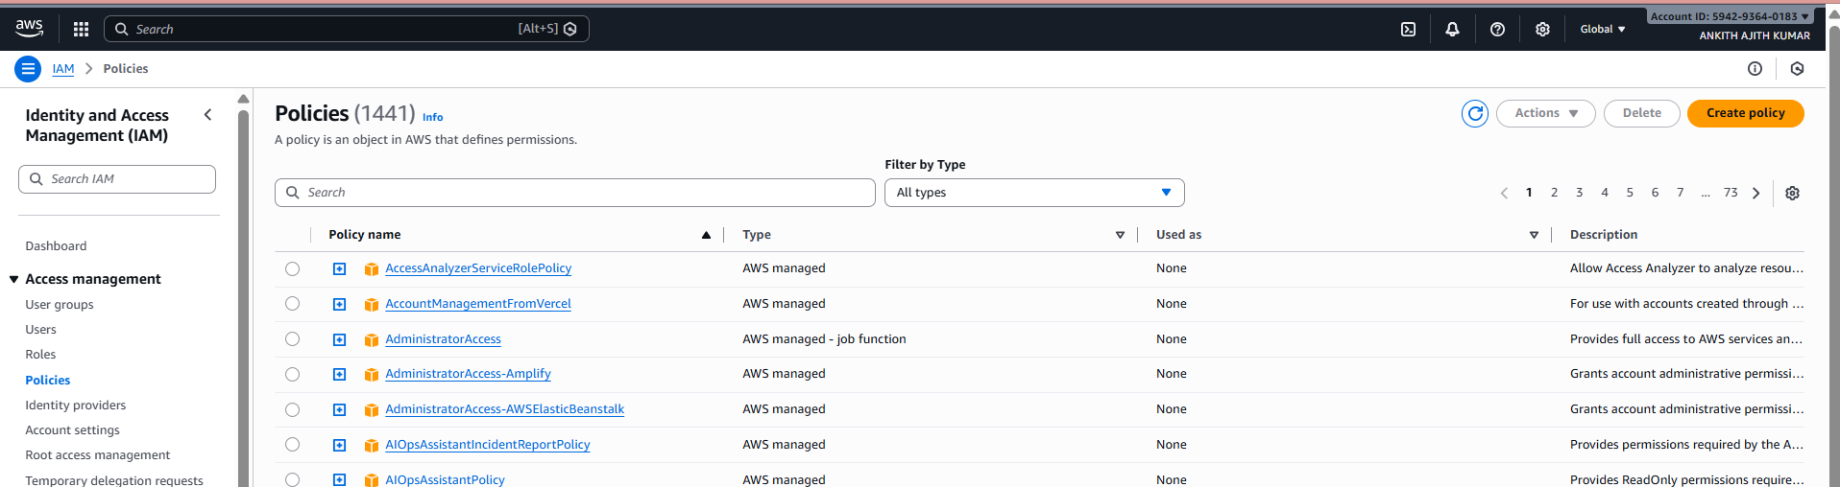

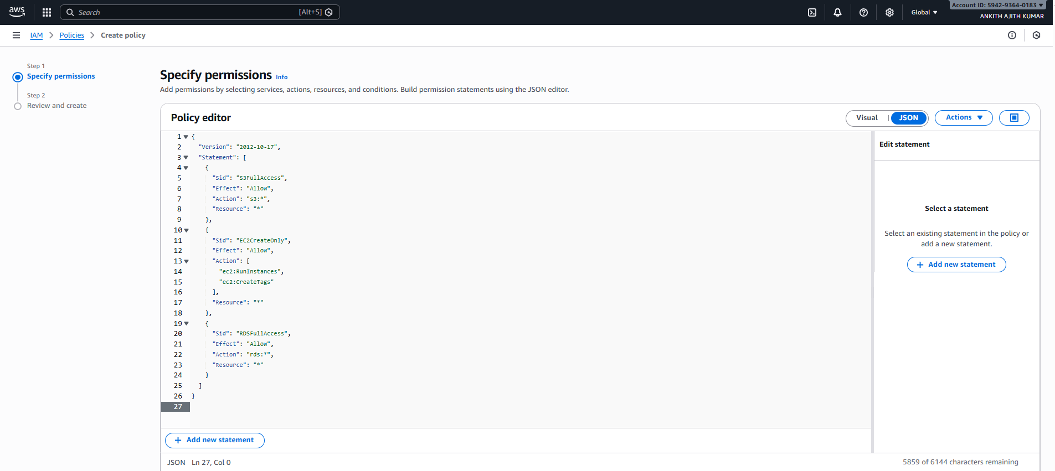

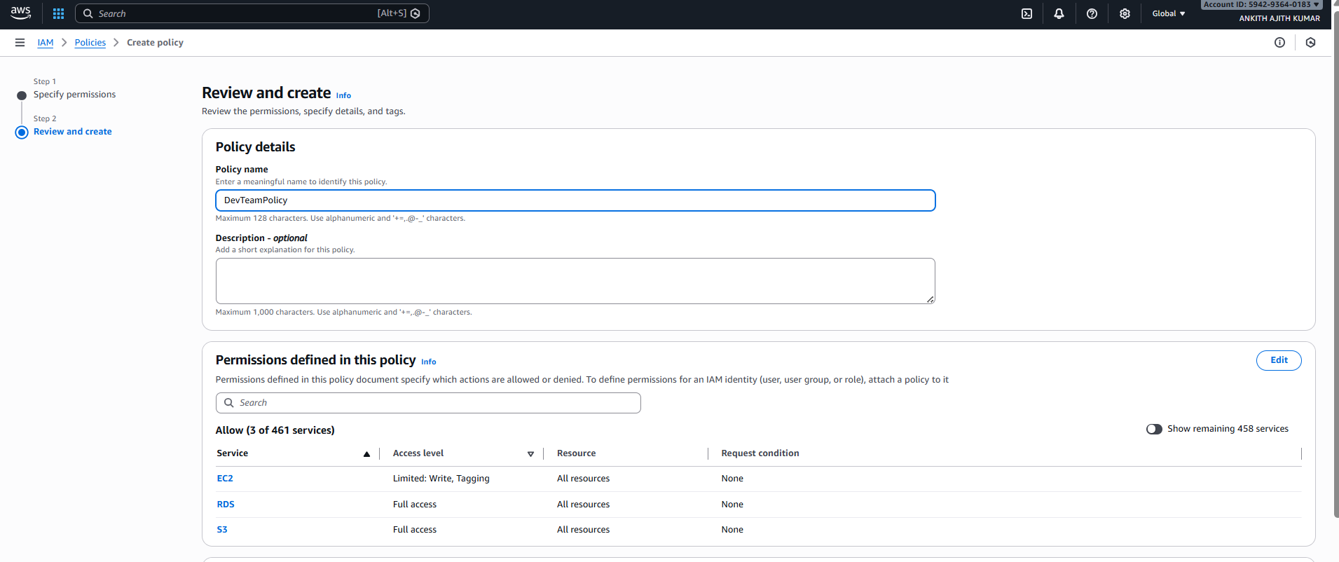
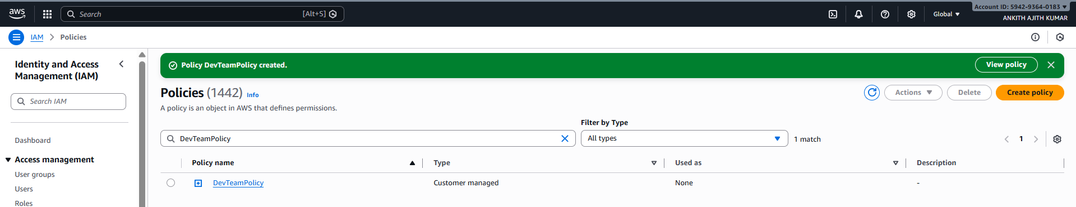

TASK 2: Create Policy Number 2 (Ops Policy)

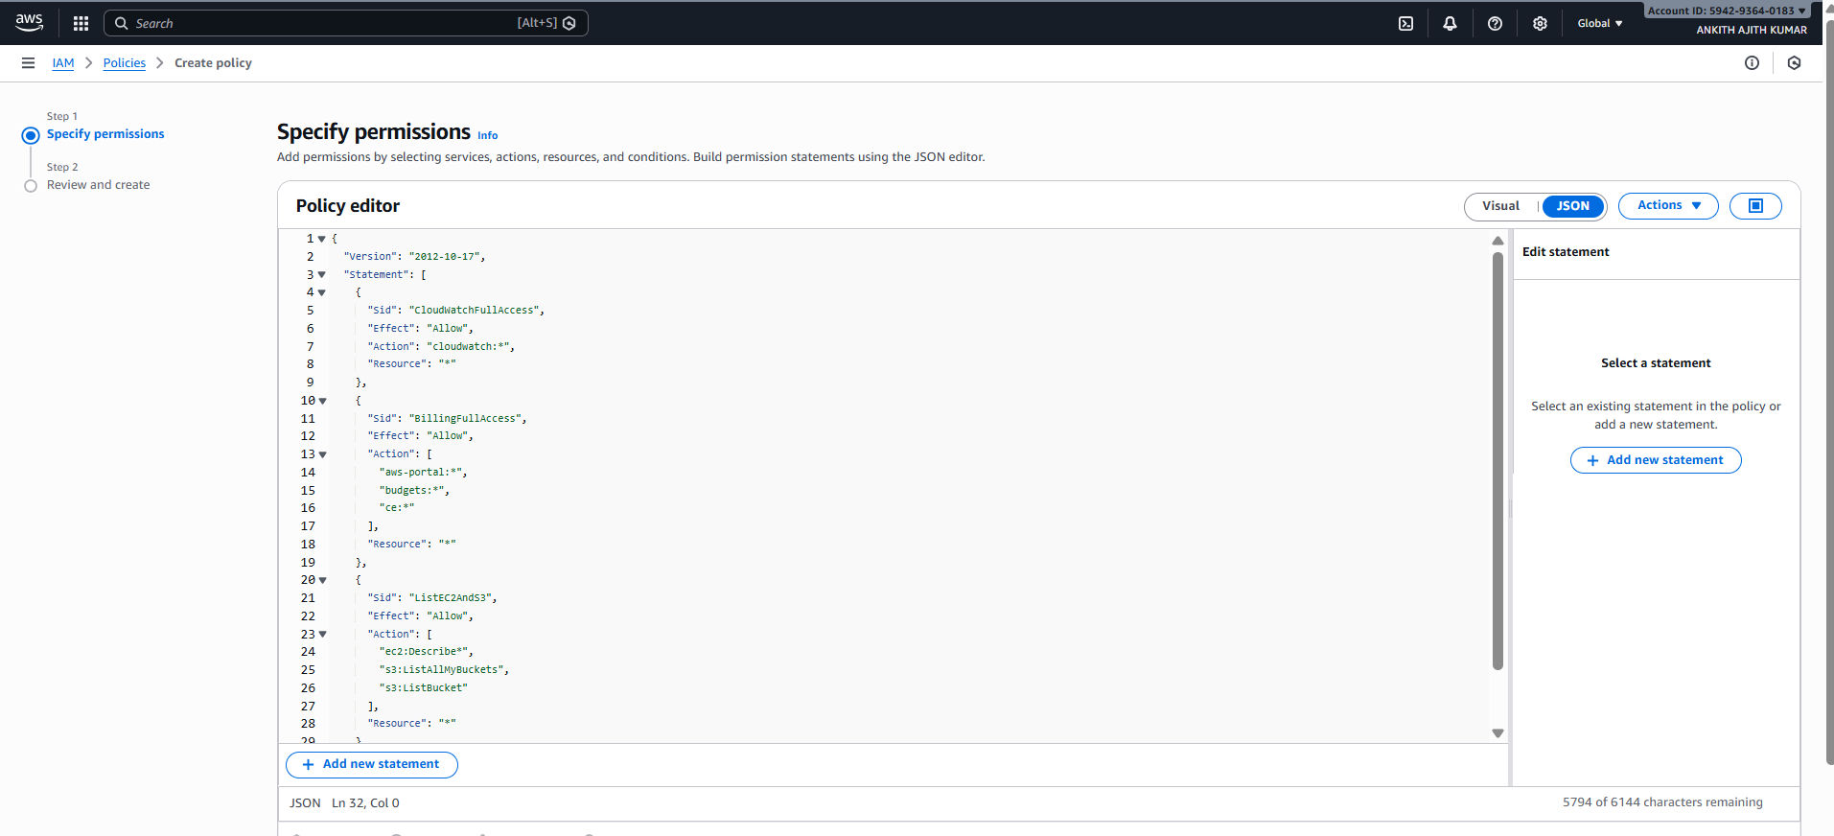
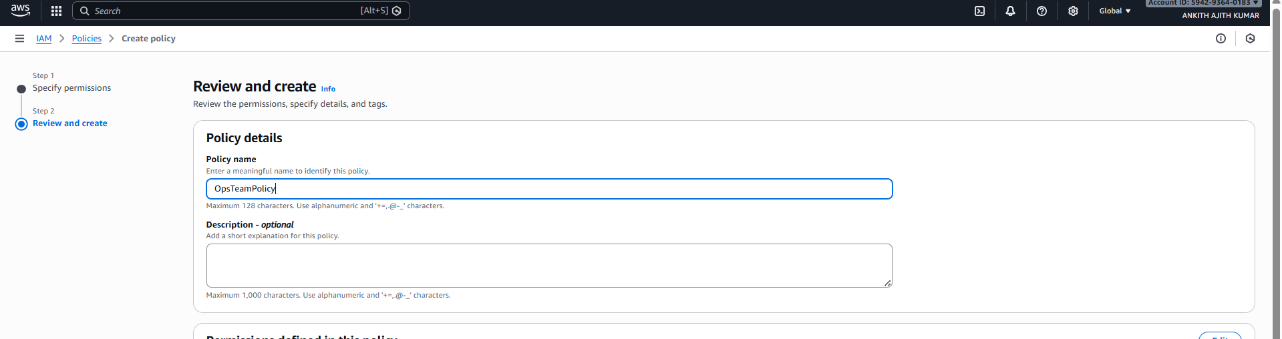
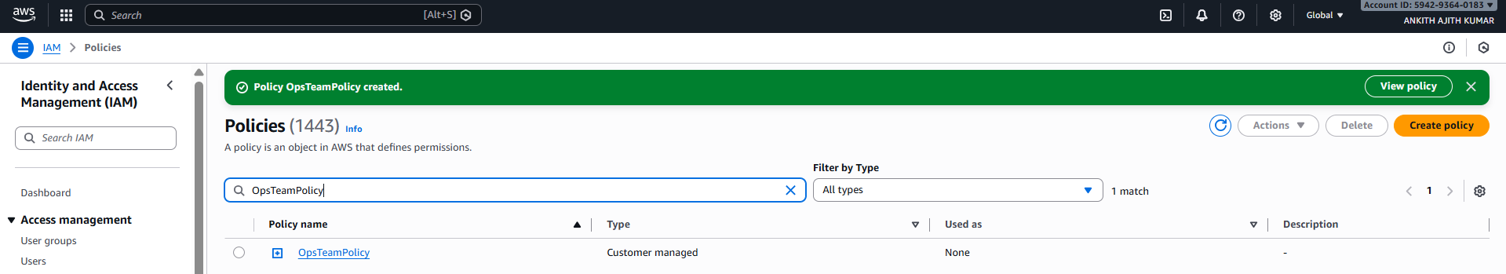

TASK 3: Attach Policy 1 to Dev Team

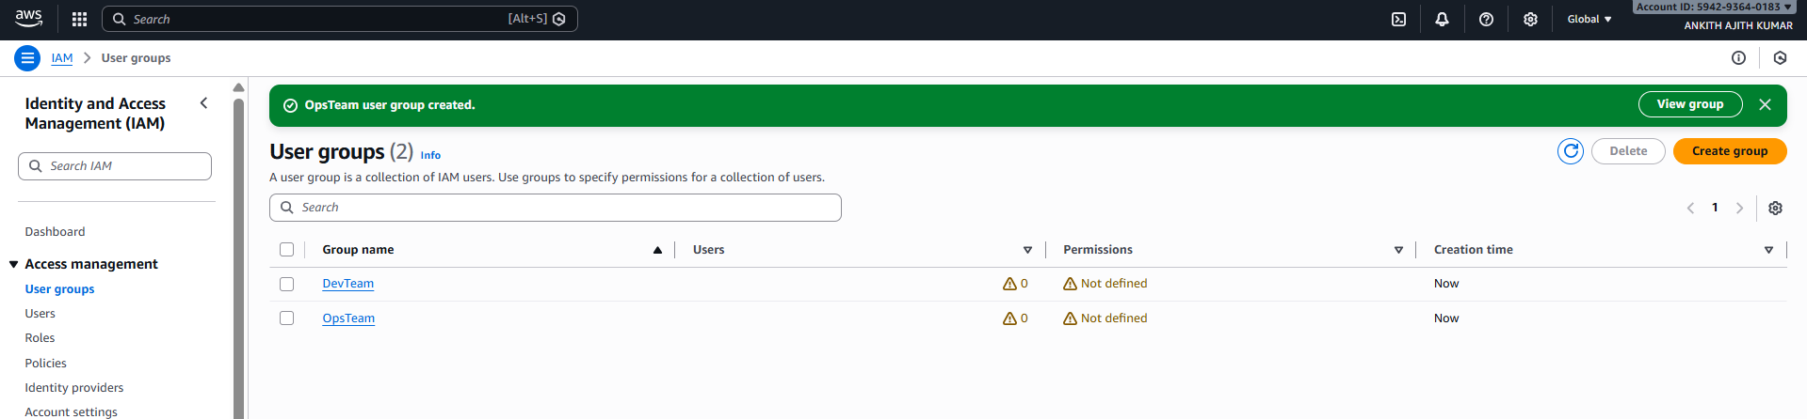

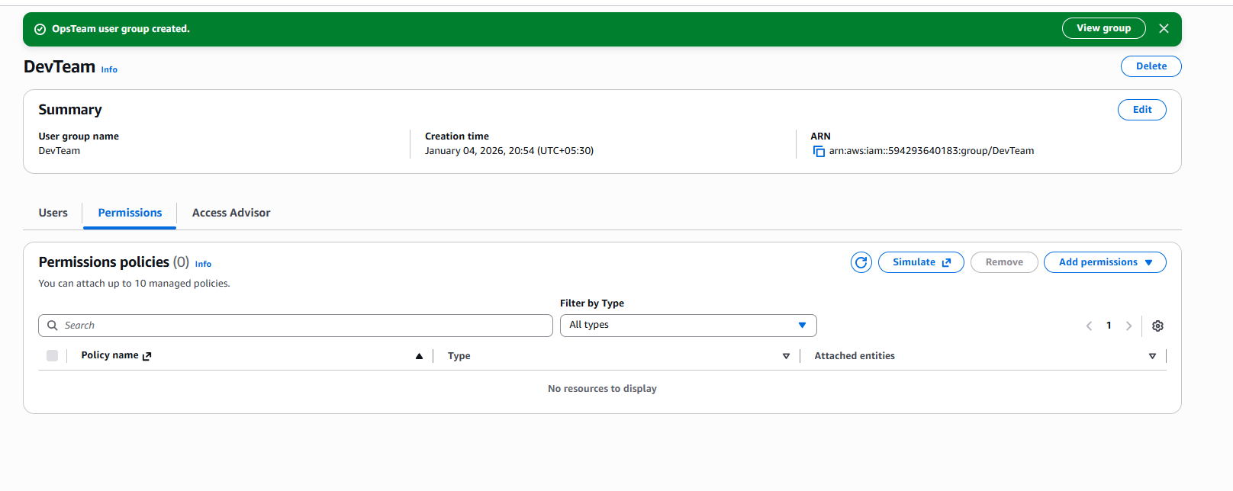
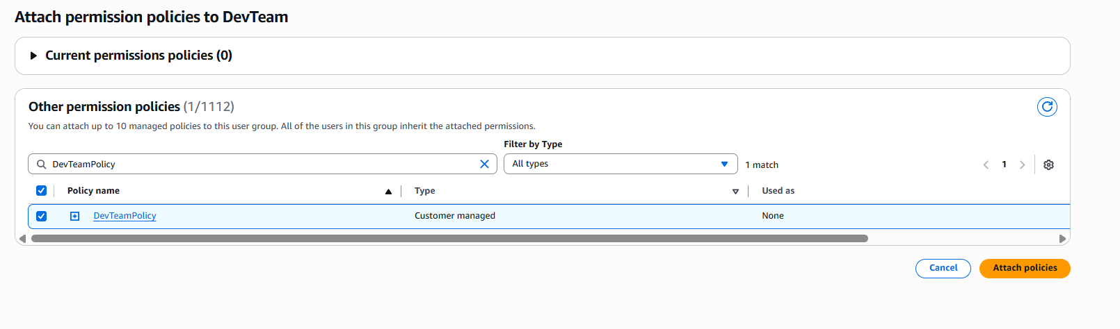
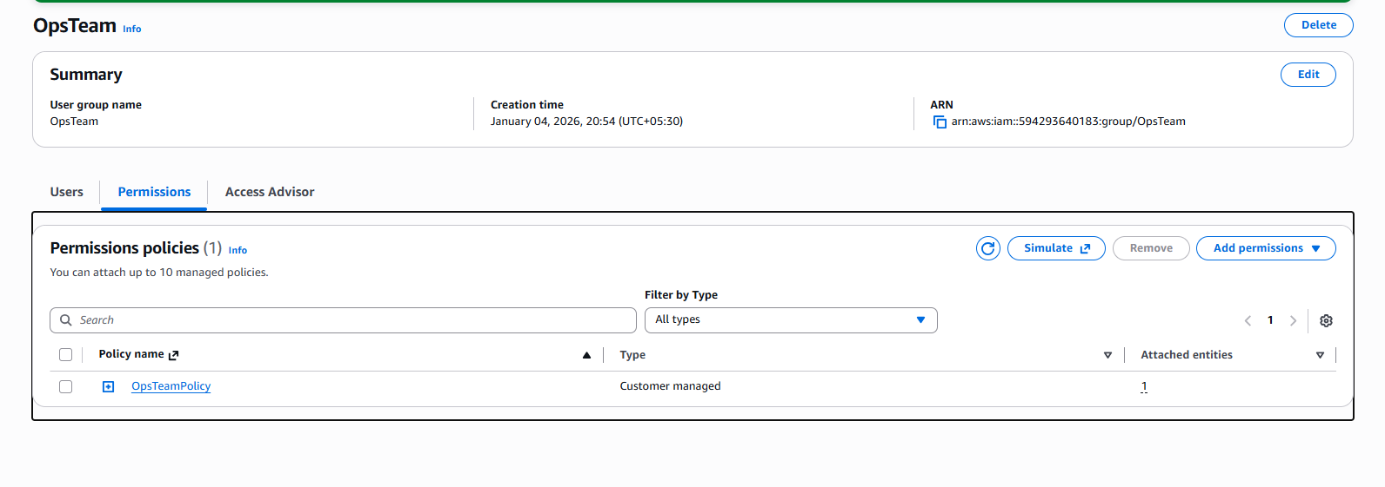

3)Problem Statement:
You work for XYZ Corporation. To maintain the security of the AWS account and
the resources you have been asked to implement a solution that can help easily
recognize and monitor the different users.
Tasks To Be Performed:
1. Create a role which only lets user1 and user2 from task 1 to have complete
access to VPCs and DynamoDB.
2. Login into user1 and shift to the role to test out the feature

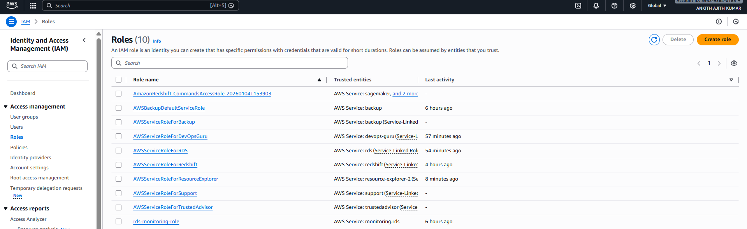
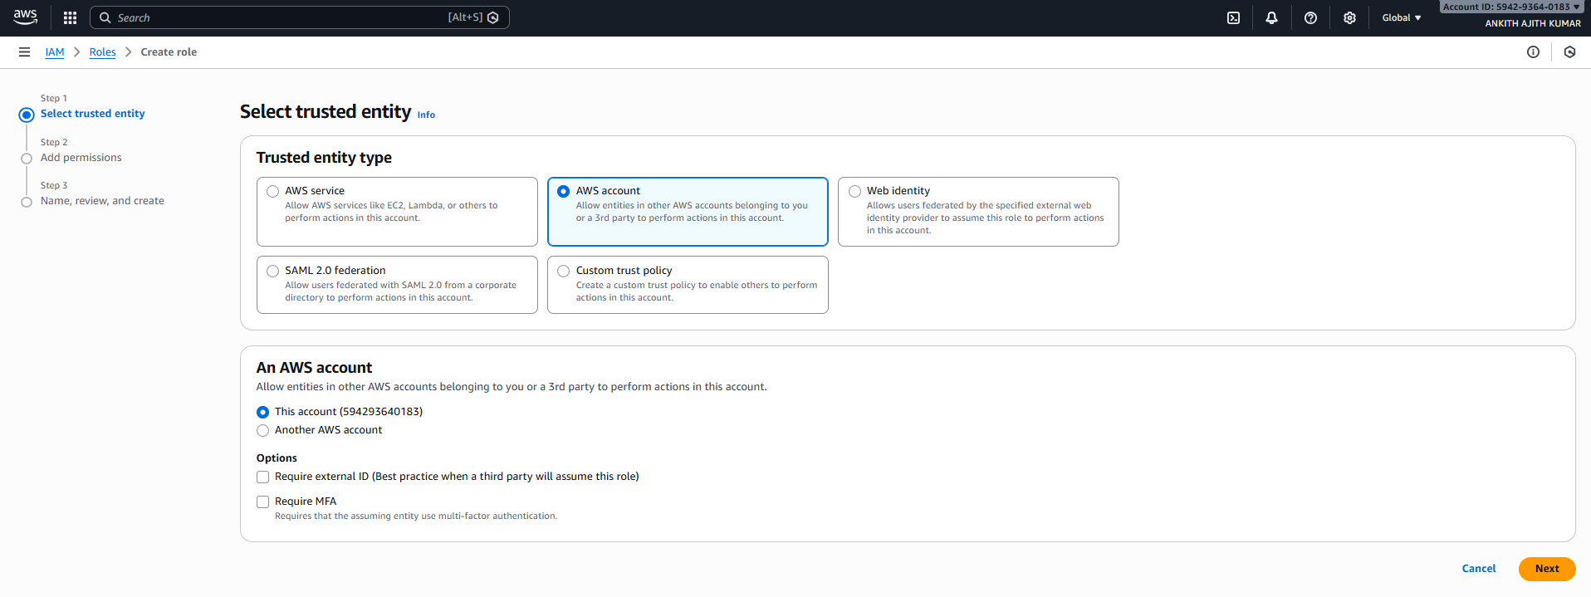
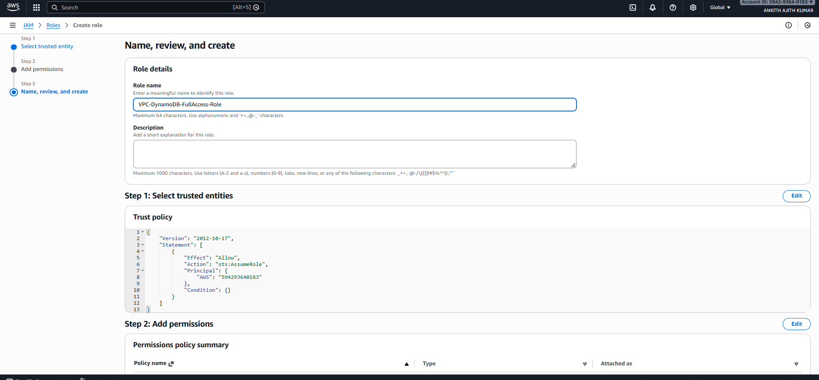

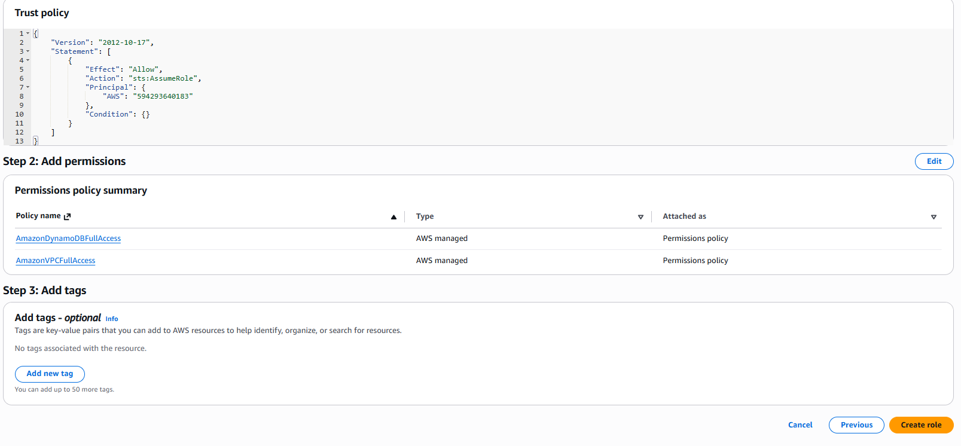
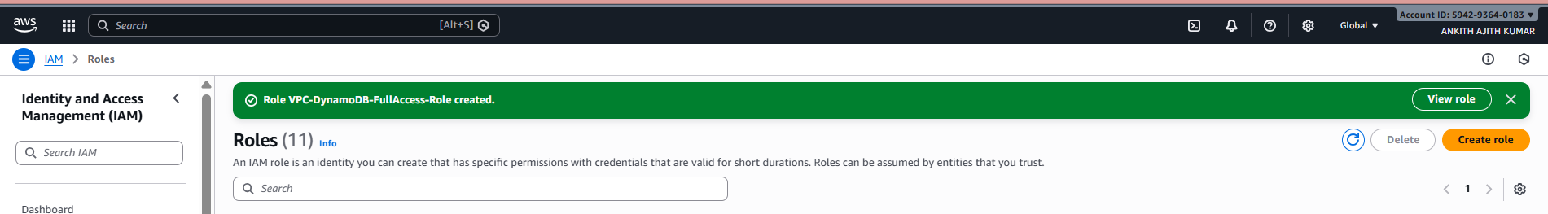

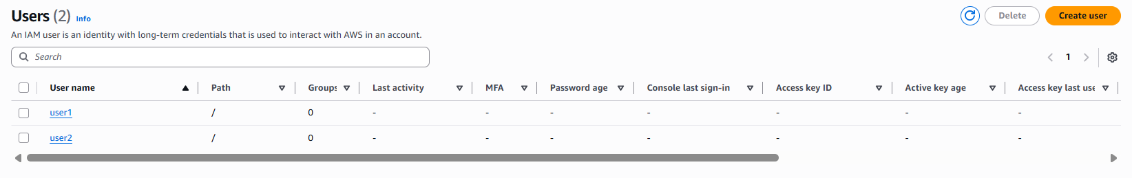
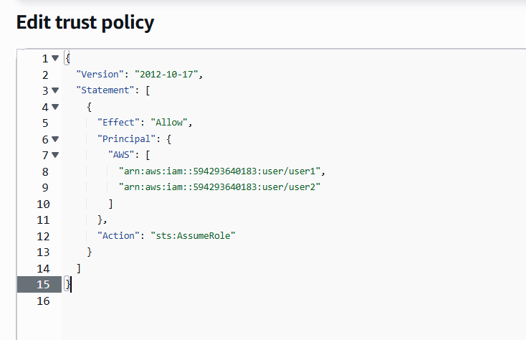

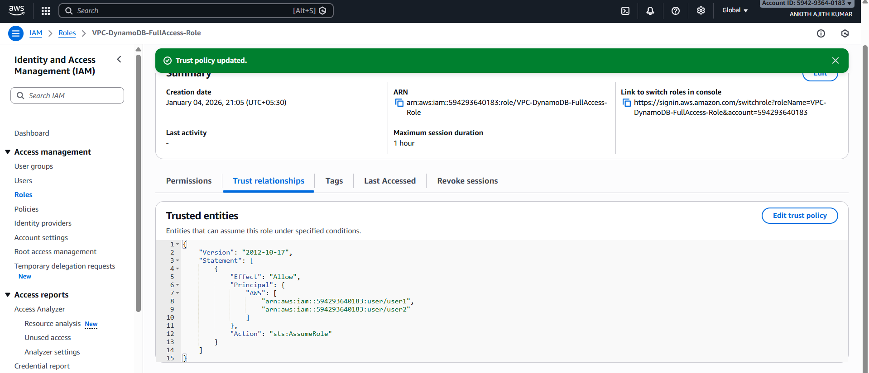
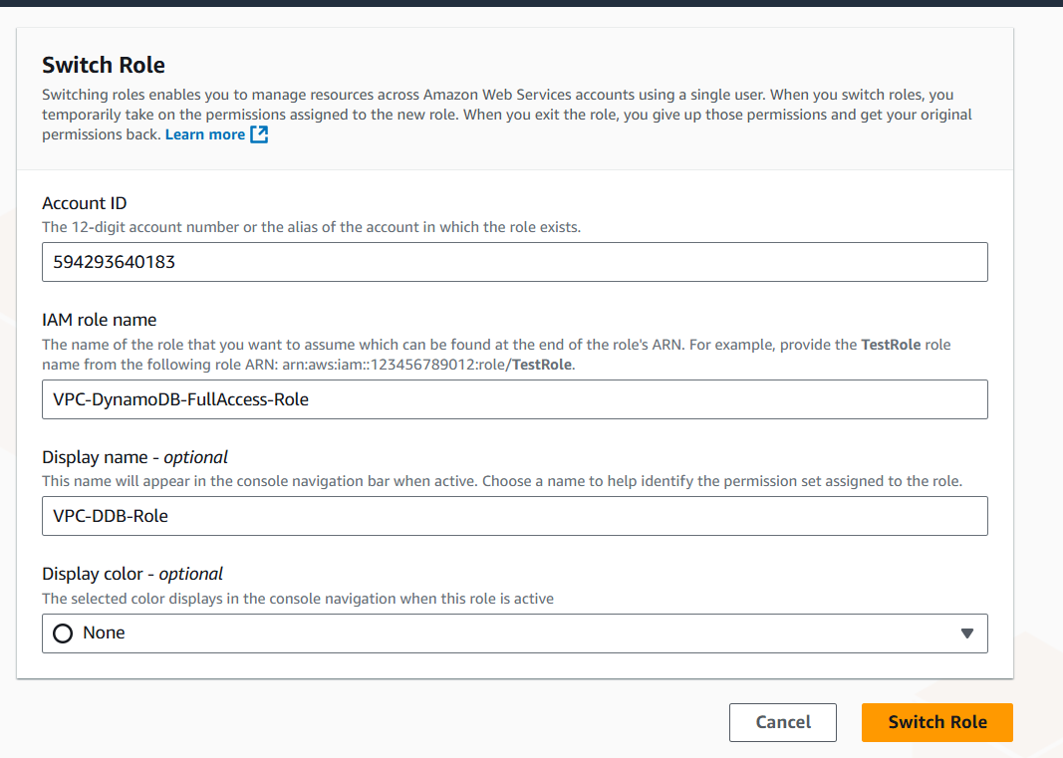

VPC-DDB-Role @ 594293640183

5) Problem Statement:
You work for XYZ Corporation. To maintain the security of the AWS account and
the resources you have been asked to implement a solution that can help easily
recognize and monitor the different users.
Tasks To Be Performed:
1. Create 4 IAM users named “Dev1”, “Dev2”, “Test1”, and “Test2”.
2. Create 2 groups named “Dev Team” and “Ops Team”.
3. Add Dev1 and Dev2 to the Dev Team.
4. Add Dev1, Test1 and Test2 to the Ops Team

TASK 1: Create 4 IAM Users

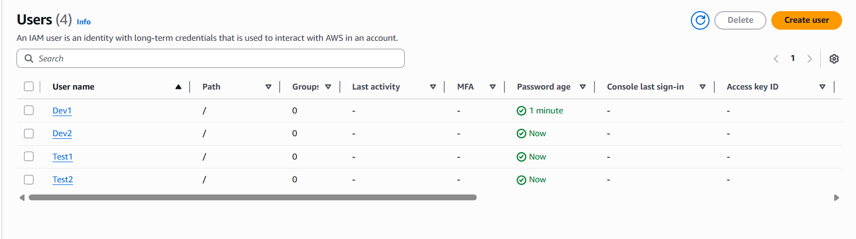

TASK 2: Create 2 IAM Groups

